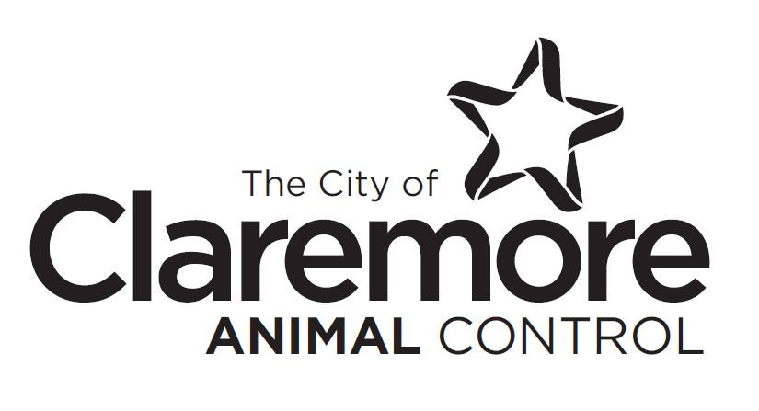
815 W Ramm Rd. Claremore, OK 74017
Phone (918) 341-1260 Fax (918) 341-5528

VOLUNTEER AGREEMENT AND RELEASE OF LIABILITY

I seek the opportunity to become a volunteer for the City of Claremore, Oklahoma. I understand that I will not get paid for my time or services, I am not officially an employee of the City of Claremore, and I may not represent myself as anything other than a volunteer. Initial ________________

I am at least 18 years of age. Initial ______________

I understand that in the course of my work I may obtain or be presented with confidential information, particularly during any work within the Claremore Police Department or with Animal Control. I agree to keep confidential any and all knowledge I may have regarding any cases, prisoners, victims, or any other information of any kind. I understand that violation of this agreement could jeopardize any investigation as well as the safety of myself and/or others. I will not discuss any aspect of the department’s work with anyone other than department personnel. Initial _________________

I understand that only official representatives of the City of Claremore are authorized to make statements to the media, and I agree not to make any statements to the media concerning information I have obtained during or as a result of my volunteer work. I understand I am not allowed to take photos at the Animal Shelter, or post photos or information on any public social media outlet unless given permission by Animal Control Officers. Initial __________________

In consideration of this opportunity, I acknowledge, understand, and accept all risks which I may be exposed to during the course of my volunteer work, and I agree on behalf of myself, my family, and my heirs, to waive any and all claims, causes of action, and/or damages of any kind or nature, including but not limited to any unforeseen personal injury, including death, animal attack, or other losses or damages, against the City of Claremore, Oklahoma, it’s employees, agents, or Officers, which may arise out of or in connection with any aspect of my volunteer work for the City of Claremore, Oklahoma, or the Claremore Animal Control unity. The City of Claremore does not provide workers comp. Initial ____________________

I am seeking the opportunity to become a volunteer for the City of Claremore voluntarily, and no promises, agreements, or other inducements have been made. I understand that the City of Claremore will rely on this statement by me, and the terms of this agreement are contractual in nature, and specifically designed to protect the City of Claremore, its employees, agents, and officers. I understand that I may terminate my agreement at any time, and that the City may do the same.

I have read and understand the above statement. I have obtained any legal advice I may need prior to signing this document, and I sign this document freely and voluntarily.

Signed this _________ day of the month of ___________________, 20______.

_______________________________ ______________________________
Signature Print Name

STATE OF OKLAHOMA }
} SS
COUNTY OF ROGERS }

On this ________ day of the month of ____________________ , 20__________.

Before me personally appeared _______________________________________.

Known to me to be the person names herein and who executed the foregoing VOLUNTEER AGREEMENT AND RELEAE OF LIABILTY and who acknowledged to me that he/she knowingly and voluntarily executed the same.

My Commission expires: _________________

Notary Public: __________________________

_________________________
City of Claremore, OK

CLAREMORE POLICE DEPARTMENT/ANIMAL CONTROL
VOLUNTEER APPLICATION

Name: _____________________________ Age: _______________D.O.B.: ____________________
Address: _________________________________________________________________________
City: ___________________State:__________ Zip Code: _____________
Social Security Number:________________________ Phone Number:________________________
E-Mail Address:_______________________________________________
Previous Addresses for last 5 years: ____________________________________________________
_________________________________________________________________________________
_________________________________________________________________________________
Employer:________________________________ Job Title:_________________________________
Business Address:___________________________________ Phone: ________________________
Previous Employer:__________________________Job Title:__________________________________
Address:___________________________________________Phone #:__________________________
Have you ever received any disciplinary action from an employer? If yes please explain. ____________
___________________________________________________________________________________
Have you ever worked for the City of Claremore? ________________________
When? ________________________What Department?______________________
Do any relatives work for the City of Claremore? _______________If yes, Name, Relation, Department:
___________________________________________________________________________________
___________________________________________________________________________________

Number of school years completed in:
High School: _______College: ___________ Graduate:______________Military Service?____________
Branch: ____________Rank: _______________Time Served: ______________Discharge:___________

Emergency Contact:
Name: _________________________________ Relationship__________________________________
Phone: _______________________Address:_______________________________________________
Have you ever applied for a position in Animal Control prior to filling out this application? If yes, please
explain:__________________________________________________________________________

Have you ever been arrested or convicted of a crime? If yes, please explain: ____________________
__________________________________________________________________________________
__________________________________________________________________________________
Do you have your own transportation? __________ Do you have proof of insurance? _______________
Driver’s license or State Id #: State ____________ ID# ___________________________

Previous Volunteer service: ___________________________________________________________
__________________________________________________________________________________
What duties would interest you the most?_________________________________________________
___________________________________________________________________________________
What is your availability? M_____________T_____________W______________U_________________
F_________________Sat________________Sun_________________

What are your special skills, hobbies and interest? __________________________________________
___________________________________________________________________________________

Membership in community or school organizations:__________________________________________
___________________________________________________________________________________

List 3 personal (not related to you) or professional references, Include Name, Address, and Phone #:

1)_________________________________________________________________________________
___________________________________________________________________________________
2)__________________________________________________________________________________
___________________________________________________________________________________
3)__________________________________________________________________________________
____________________________________________________________________________________

I understand and agree that any false statement, either verbal or written, may cause the applicant’s name to be removed from the eligibility list or be cause for immediately dismissal as a volunteer with the City of Claremore if an appointment is/was made.

I hereby authorize the Claremore Police Department to make a thorough investigation of my entire work, personal and financial history and verify all data in my application, related papers and/or oral interviews. I authorize such investigation and the given and receiving of any information requested by the Claremore Police Department and I release from liability and person giving or receiving such information. I understand that falsification of data so given or other derogatory information discovered as a result of this investigation may prevent my appointment or, if appointed, may subject me to immediate dismissal.

Signature:__________________________________________ Date:__________________________
Witness: ___________________________________________ Date: __________________________

Claremore Animal Control/Animal Shelter Volunteer Rules
Please initial after you have read each of the following

When you confirm a time to work, we will treat this like a job. If you no show/no call more than 2 times we will assume you no longer wish to volunteer and your status will be revoked. ______________

We have an established system that works, and we are looking out for your safety. If you do not follow our instructions, directions, or direct orders, your status will be revoked. ______________

If we have concerns in your attitude, behavior, or work ethic, we have the right to revoke your status. We have to be able to trust you, rely on you to do a good job in a timely manner, and you may be exposed to the public. Your attitude and ability to do this job in a quality manner determine if we want you to continue to work with us. ___________

Your tasks are our tasks. The work we ask you to do is the same work we do every day when we don’t have help. You are assisting us in our day to day operations, and sometimes it gets dirty. ___________

Work Apparel. No sandals or open toe shoes. No shorts. You most likely will get dirty. Wear apparel you will be ok in, if it gets ruined. You may be exposed to cleaning fluids such as bleach, sanitizer, other custodial cleaners, and animal fluids such as urine, fecal matter, blood, and slobber. _______________

Allergy issues. If you have any type of animal allergy, you will be exposed to it every day and in every part of the facility. ____________

Feeding of animals is on a schedule. Do not feed the animals without permission of a Shelter Employee. Treats are ok but should be cleared by Shelter employee. ____________

Information cards need to stay with the animal. If you move an animal. Make sure you move the information card with the animal. _____________

If a card says “Caution” or “Do not touch” then do NOT attempt to open the kennel or handle the animal. If you are caught handling an animal we deem unsafe, you will be asked to leave and your status will be revoked. If there is an animal that you feel uncomfortable handling, please let us know and we can assist in safe handling. ___________

All volunteers must report any incidents to an employee. Any information about an animal is helpful, but please never conceal information if an animal tried to bite or show aggressive tendencies. If you observe any medical needs, please report immediately to employees. If you attempt to treat any medical need yourself, you will be asked to leave and status revoked. ___________

When walking animals outside, please clean up after them. We need to keep all animals healthy and want to prevent as little cross contamination as possible. ____________

When walking a dog, the dog must be kept on a leash and under reasonable control. Many do jump up on you and/or want to run. If you feel you cannot control a dog or are uncomfortable with it, then do not attempt to walk it and just inform an employee. _________

Clean up after yourself. We are all adults, if you make a mess clean it up. This not only helps keep the shelter clean, but safety also may be an issue of concern. ___________

We are a city department; therefore, we do not accept animals from outside our jurisdiction. If someone contacts you, do not instruct them to bring the animal to the shelter, but have them speak to an employee during normal business hours. ____________

You do not have the authorization to approve adoptions or animal status changes. You may be asked to assist the public in meeting and showing animals, but shelter employees will make final approval and do the required paperwork. If you attempt to interfere with any animal processes, you will be asked to leave and your status will be revoked. ______________

If you do not volunteer for an extended amount of time (over 6 months) without previous arranges made, you will be removed from the contact list and made have to reapply. ___________

The Claremore Animal Shelter and its contents including the animals are property of the City of Claremore. This property will be treated as such and not abused, any abuse of animals or property will mean immediate dismissal as a volunteer and may include prosecution. _______________

These guidelines are for the safety of the volunteer, the citizens that visit the shelter as well as the shelter employees and the animals held here. By signing below, means I understand and will abide by the above listed regulations.

Signature: __________________________________________ Date: ___________________________
Print Name as above signed: ____________________________________

Witness signature: __________________________Print Name: ________________________________
Address: _____________________________________________Phone #________________________

