What is a Riparian Area?  A riparian area is the vegetated area adjacent to lakes, rivers, streams and ditches that provides bank stabilization which helps prevent erosion. Keeping this natural vegetation area in place protects water quality. This is done by the overgrown vegetation trapping and filtering sediment and pollutants before they enter the waterway. Riparian area protection is one of the easiest, economical, and most beneficial ways to preserve water quality and stream habitat. |  | Trees & Shrubs  - Shumard Oak  - Pecan  - Oak  - Willow  - Cottonwood  - Deciduous Holly  - Maple  - Rusty Blackhaw  - Elm  - Button Bush  Native Plants to Use Near Streams  For more information, please contact:  Julie Monnot, Stormwater Manager at  918-341-0457 ext285 jmonnot@claremorecity.com  Kyle Clifton, Floodplain Manager at  918-341-2066 ext213 kclifton@claremorecity.com | Flowers & Grasses  - Cattail  - Smart Weed  - Sweet Grass  - Cardinal Flower  - Pond Arrowhead  - Cinnamon Fern  - Blazing Star |  | How to Properly Maintain Stormwater Channels  - The City of Claremore’s Citizen Guide to Maintaining Stormwater Structures on Your Property  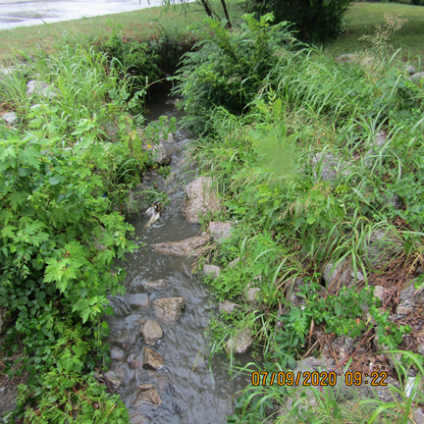

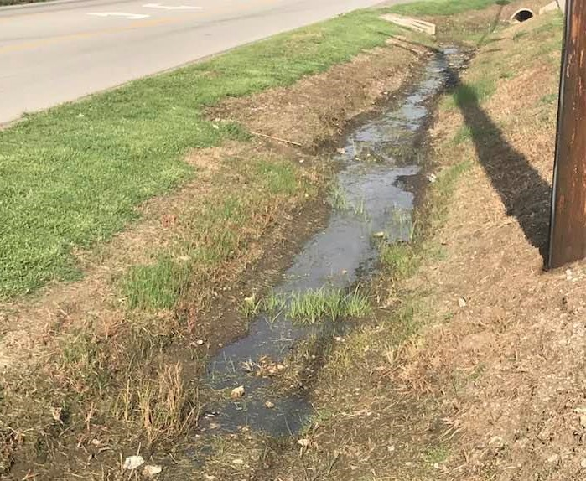  Here is an example of how herbicide use can cause pollution and erosion problems.  Citizen Obligations  According to The City of Claremore’s ordinance, citizens who have a stormwater ditch, structure or stream on their property are obligated to keep the watercourse free of trash, debris, excessive vegetation and other obstacles that could pollute or impede water flow.  City of Claremore Obligations  The City is responsible for all grading, excavation or alteration of flow in streams and ditches. It is against state law for citizens to alter flow of any waterway without a permit. | Riparian Area Protection  The Dos  - Use herbicides, pesticides and fertilizers excessively. Stop using them, if possible.  - Add or take away any dirt, gravel or soil from eroding stream bank. Altering a stream in this way requires a permit.  - Mow right up to the edge of the waterway.  The Don’ts  - Leave the area next to the stream bank or ditch unmowed.  - Plant native plants and trees next to the stream bank.  - Try to eliminate invasive species next to streams.  - Keep the stream bed clear of trash, materials or vegetation that could impede the flow of the stream or cause flooding.  - Keep dirt & other materials from filling in the stream or ditch. | 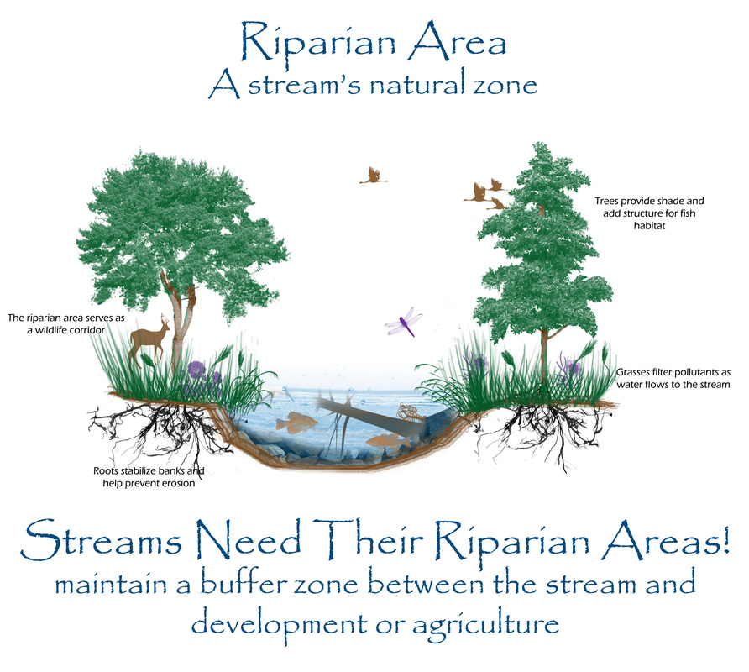  We Can All Help Nature Out  By letting nature occur naturally allowing the area next to streams and ditches grow, we help preserve water quality and the natural function of streams for ourselves and wildlife. In doing this, we are actually making less work for ourselves and saving money by not using chemicals. Citizens can also plant native plants in the riparian area for even more of a benefit to nature.

