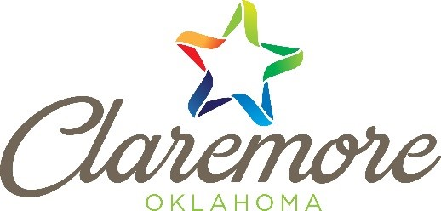
It’s Time to Talk Trash
One of the major functions of a municipality is the disposal of waste from its citizens and businesses. By taking on this task municipalities also take on the responsibility of making sure the wastes put in our receptacles won’t harm the environment, the facilities where the trash goes to or the people who transport the trash. Listed below are the items which the City of Claremore cannot take.
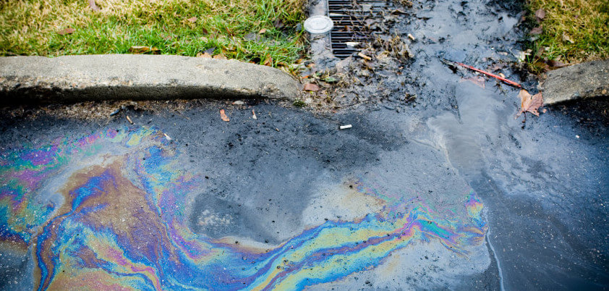
Liquids should not put into the trash because they can leak out of trash trucks onto the ground causing pollution.
Prohibited Substances:
- Liquids, Including Paint: Liquids & paint can leak out of trash trucks and become pollutants in our environment.
- Batteries. Batteries have the potential to start fires in trucks and in landfills.
- Sharps & Medication. Medication can be disposed at local police stations. Consult with your Dr. on sharps disposal.
It’s Time to Talk Trash
One of the major functions of a municipality is the disposal of waste from its citizens and businesses. By taking on this task municipalities also take on the responsibility of making sure the wastes put in our receptacles won’t harm the environment, the facilities where the trash goes to or the people who transport the trash. Listed below are the items which the City of Claremore cannot take.
Liquids should not put into the trash because they can leak out of trash trucks onto the ground causing pollution
Prohibited Substances:
- Liquids, Including Paint: Liquids & paint can leak out of trash trucks and become pollutants in our environment.
- Batteries. Batteries have the potential to start fires in trucks and in landfills.
- Sharps & Medication. Medication can be disposed at local police stations. Consult with your Dr. on sharps disposal.
It’s Time to Talk Trash
One of the major functions of a municipality is the disposal of waste from its citizens and businesses. By taking on this task municipalities also take on the responsibility of making sure the wastes put in our receptacles won’t harm the environment, the facilities where the trash goes to or the people who transport the trash. Listed below are the items which the City of Claremore cannot take.
Liquids should not put into the trash because they can leak out of trash trucks onto the ground causing pollution
Prohibited Substances:
- Liquids, Including Paint: Liquids & paint can leak out of trash trucks and become pollutants in our environment.
- Batteries. Batteries have the potential to start fires in trucks and in landfills.
- Sharps & Medication. Medication can be disposed at local police stations. Consult with your Dr. on sharps disposal.

- Metals. Car parts, particularly large ones, can cause damage to trash truck can be recycled.
- Toxic substances. Pool, lawn, household, construction and car chemicals can leak and cause pollution.
- Compressed Gas Containers. Due to possible explosive substances.
- Tree Stumps. Large limbs and stumps damage equipment.
- For information on disposing of chemicals properly please visit www.claremorecity.com/enviornmental or call 918-341-0457 ext. 285 or email jmonnot@claremorecity.com
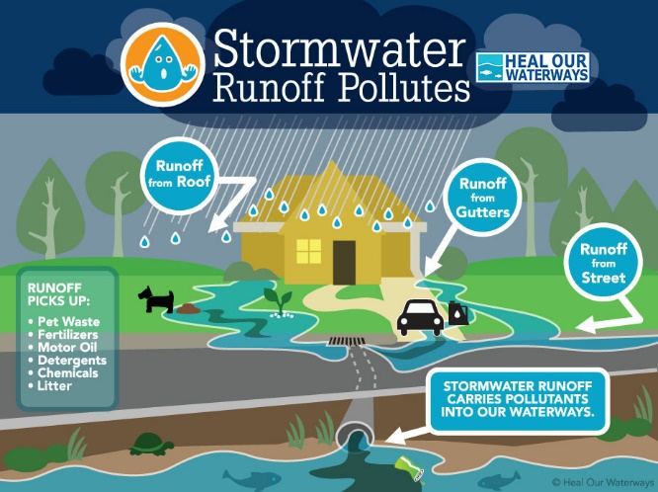
- Space Carts Properly. Make sure your trash lids are closed and spaced 3 feet away from other objects.
- For Recycling Resources please call The M.E.T at 918-584-0584 or visit their website at www.metrecycle.com for more information on chemical disposal.
We can all do our part to prevent pollution, and keep our land and water clean and healthy. For more information please visit the City of Claremore’s website at: https://www.claremorecity.com/315/Stormwater or call the Stormwater Manager, Julie Monnot at:
918-341-0457 ext. 285
- Metals. Car parts, particularly large ones, can cause damage to trash truck can be recycled.
- Toxic substances. Pool, lawn, household, construction and car chemicals can leak and cause pollution.
- Compressed Gas Containers. Due to possible explosive substances.
- Tree Stumps. Large limbs and stumps damage equipment.
- For information on disposing of chemicals properly please visit www.claremorecity.com/enviornmental or call 918-341-0457 ext. 285 or email jmonnot@claremorecity.com
- Space Carts Properly. Make sure your trash lids are closed and spaced 3 feet away from other objects.
- For Recycling Resources please call The M.E.T at 918-584-0584 or visit their website at www.metrecycle.com for more information on chemical disposal.
We can all do our part to prevent pollution, and keep our land and water clean and healthy. For more information please visit the City of Claremore’s website at: https://www.claremorecity.com/315/Stormwater or call the Stormwater Manager, Julie Monnot at:
918-341-0457 ext. 285

- Metals. Car parts, particularly large ones, can cause damage to trash truck can be recycled.
- Toxic substances. Pool, lawn, household, construction and car chemicals can leak and cause pollution.
- Compressed Gas Containers. Due to possible explosive substances.
- Tree Stumps. Large limbs and stumps damage equipment.
- For information on disposing of chemicals properly please visit www.claremorecity.com/enviornmental or call 918-341-0457 ext. 285 or email jmonnot@claremorecity.com
- Space Carts Properly. Make sure your trash lids are closed and spaced 3 feet away from other objects.
- For Recycling Resources please call The M.E.T at 918-584-0584 or visit their website at www.metrecycle.com for more information on chemical disposal.
We can all do our part to prevent pollution, and keep our land and water clean and healthy. For more information please visit the City of Claremore’s website at: https://www.claremorecity.com/315/Stormwater or call the Stormwater Manager, Julie Monnot at:
918-341-0457 ext. 285

