Leaves and Grass are not Meant for Storm Drains.  When organic materials are blown into the storm drain it creates problems both physically and chemically.  When grass and leaves are blown into the street and storm drains it creates a physical hazard by blocking flow of stormwater which can create drainages problems that can lead to localized flooding.  Additionally, when grass and leaves do make it to our waterways they will decompose using and depleting the available oxygen for that process. Leaving the water unable to support aquatic life.  By disposing of leaves and grass properly we can prevent these problems. |  | Possible yard flower options:  - Monarda (Bee Balm)  - Echinacea (Coneflower)  - Gaillardia (Indian Blanket)  - Asclepias (Milkweed)  - Aster  - Rudbeckia (Black Eye Susan)  - Solidago (Goldenrod)  Planting flowers reduces the amount of grass to mow and creates habitat for insect and wildlife.  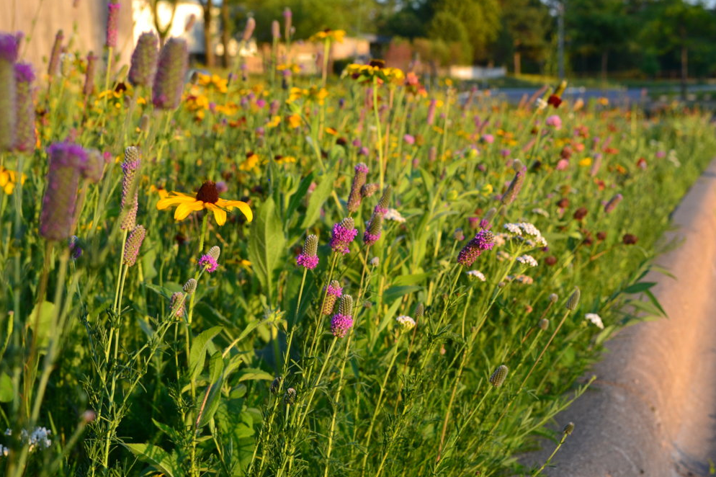  For more information, contact:  Julianna Monnot  Stormwater Manager  918-341-0457 ext. 285  jmonnot@claremorecity.com | Choose to Sow Not Mow |  | No Grass or Leaves Please  - City of Claremore’s Guide to Proper Landscape Material Disposal  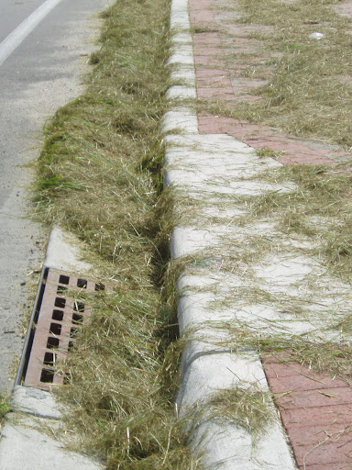  Organic materials, such as leaves and grass, deplete oxygen from water when they decompose which living things need to survive.

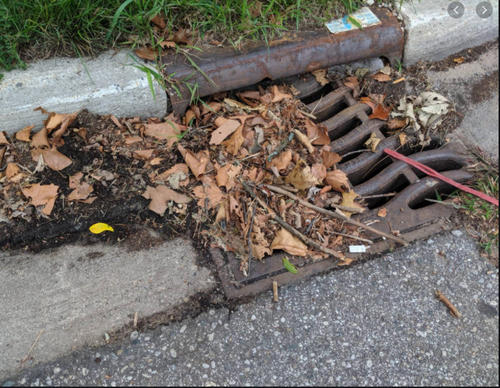  Disposal Options  There are several ways to dispose of your lawn waste. Some are better than others. Listed below are the options and some info about each option.  - Use a mulching mower. This is the easiest. Mulching grass & leaves it eliminates the need for fertilizer and returns nutrients back to the soil.  - Composting. Grass can be a great addition to kitchen compost that can produce healthy soil for future use.  - Use the green waste site. After severe storm events the city may have storm debris pick-up. Visit the City of Claremore’s website for info. | “Unless someone like you cares a whole awful lot, nothing is going to get better, it’s not”  Dr. Seuss “The Lorax”  Other Ways to Help  - Plant a pollinator garden. This reduces the amount of grass needing to be mowed.  - Plant Buffalo Grass. This is a native Oklahoma prairie grass and does not grow very tall and is hardy in our climate  - Use a fire pit. Fire Pits can be useful for burning sticks and branches. Bonus: it helps deter mosquitos. They hate smoke.  Using These Methods Can Save Time & Money  To have the City of Claremore come and pick up your yard waste there is a minimum charge of $50. For more information contact the city utility office at 918-341-0456. | Municipal Sewer Systems  The City of Claremore has two types of sewers.  - Sanitary sewer- Drains from your indoor house drains. To the waste water treatment plant. Where the water is cleaned before being discharged to the lake, river, or stream.  - Storm Sewer- Drains from the street drains or ditches and does NOT get cleaned before going into our lakes, rivers and streams.  Storm Drains Are Not for Grass  Remember it is illegal to blow are sweep grass, leaves or other debris into the city’s storm drains.  To Schedule a Brush or Yard Waste Pick-up Contact:  City of Claremore  918-341-0456 or visit  https://www.claremorecity.com/286/Brush-Pick-Up

