Taking Care of Your Pet and the Planet
It is estimated almost 60% of Americans own pets. More than half of which are dogs. Dogs, as we know go outside to go poo. What many Americans don’t know is their poos can pollute our water unless picked up an properly disposed of.
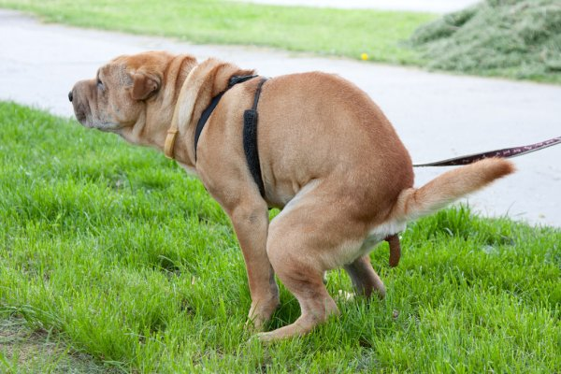
It is illegal not pick up after your pet either on your own personal property or in public areas.
There are a couple of options for disposing of your pet’s waste.
- Disposal into the sanitary sewer system. As you are walking your pet you can take a container to pick up the waste and empty it into the toilet when you get home. Note: do not dispose of any bags or wet wipes down the sanitary sewer. It will clog pipes.

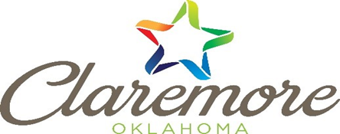
Taking Care of Your Pet and the Planet
It is estimated almost 60% of Americans own pets. More than half of which are dogs. Dogs, as we know go outside to go poo. What many Americans don’t know is their poos can pollute our water unless picked up an properly disposed of.
It is illegal not pick up after your pet either on your own personal property or in public areas.
There are a couple of options for disposing of your pet’s waste.
- Disposal into the sanitary sewer system. As you are walking your pet you can take a container to pick up the waste and empty it into the toilet when you get home. Note: do not dispose of any bags or wet wipes down the sanitary sewer. It will clog pipes.
Taking Care of Your Pet and the Planet
It is estimated almost 60% of Americans own pets. More than half of which are dogs. Dogs, as we know go outside to go poo. What many Americans don’t know is their poos can pollute our water unless picked up an properly disposed of.
It is illegal not pick up after your pet either on your own personal property or in public areas.
There are a couple of options for disposing of your pet’s waste.
- Disposal into the sanitary sewer system. As you are walking your pet you can take a container to pick up the waste and empty it into the toilet when you get home. Note: do not dispose of any bags or wet wipes down the sanitary sewer. It will clog pipes.

- Disposal onto your property. Your pet’s waste can also be disposed of properly into your yard as well. To do so, dig a hole at least 6 inches deep and deposit pet waste in the hole and cover it with dirt. This will prevent harmful bacteria from entering our storm sewer system. Do not dispose of pet waste in the compost pile.
- The third option is to dispose of it in the trash. The bag and all can be disposed of in the trash. If possible choose biodegradable bags.
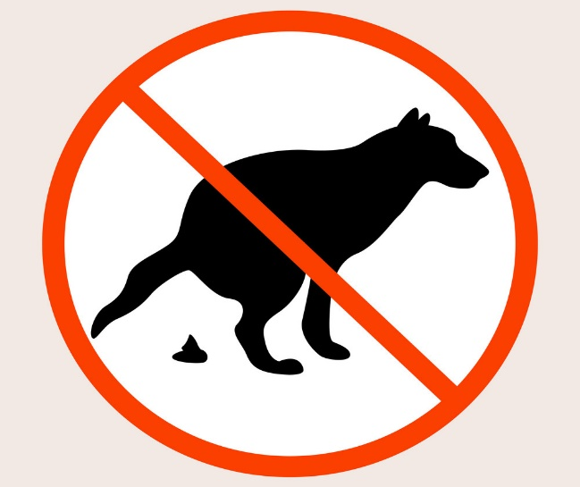
It is important to pick up after your pet in public and private areas because the bacteria in their feces can cause illness. These bacteria can be transmitted by direct contact or be carried in stormwater to our lakes, rivers or streams. Please do your part to prevent this type of pollution.

If you have any question about pet waste disposal please reference our website at https://www.claremorecity.com/299/Water-Pollution or call 918-341-0457 ext. 285

- Disposal onto your property. Your pet’s waste can also be disposed of properly into your yard as well. To do so, dig a hole at least 6 inches deep and deposit pet waste in the hole and cover it with dirt. This will prevent harmful bacteria from entering our storm sewer system. Do not dispose of pet waste in the compost pile.
- The third option is to dispose of it in the trash. The bag and all can be disposed of in the trash. If possible choose biodegradable bags.
It is important to pick up after your pet in public and private areas because the bacteria in their feces can cause illness. These bacteria can be transmitted by direct contact or be carried in stormwater to our lakes, rivers or streams. Please do your part to prevent this type of pollution.

If you have any question about pet waste disposal please reference our website at https://www.claremorecity.com/299/Water-Pollution or call 918-341-0457 ext. 285

- Disposal onto your property. Your pet’s waste can also be disposed of properly into your yard as well. To do so, dig a hole at least 6 inches deep and deposit pet waste in the hole and cover it with dirt. This will prevent harmful bacteria from entering our storm sewer system. Do not dispose of pet waste in the compost pile.
- The third option is to dispose of it in the trash. The bag and all can be disposed of in the trash. If possible choose biodegradable bags.
It is important to pick up after your pet in public and private areas because the bacteria in their feces can cause illness. These bacteria can be transmitted by direct contact or be carried in stormwater to our lakes, rivers or streams. Please do your part to prevent this type of pollution.

If you have any question about pet waste disposal please reference our website at https://www.claremorecity.com/299/Water-Pollution or call 918-341-0457 ext. 285

