

**Pool & Hot Tub Water Disposal**

Spring is upon us and with spring comes the time to prepare for summer. For those residents with pools this means draining and cleaning the pool. Before citizen embark on the spring pool cleaning we would like you to keep some things in mind.

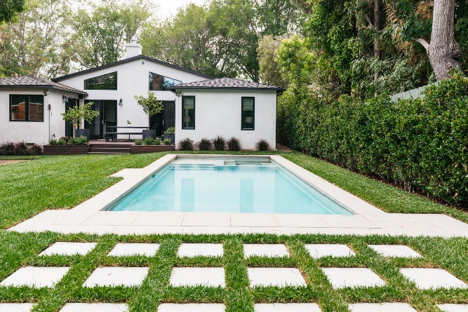

**It is illegal to dispose of pool water contaminated with chlorine or other substances into the storm sewer system.**

There are two options for disposing of pool and hot tub water.

**Disposal into the sanitary sewer system.** To do this a few steps must be taken.

* Discontinue adding chlorine and other chemicals 3 days before disposing of the water into the cleanout in your yard.
* Pool water must meet current ordinances for sanitary sewer disposal



**Pool & Hot Tub Water Disposal**

Spring is upon us and with spring comes the time to prepare for summer. For those residents with pools this means draining and cleaning the pool. Before citizen embark on the spring pool cleaning we would like you to keep some things in mind.



**It is illegal to dispose of pool water contaminated with chlorine or other substances into the storm sewer system.**

There are two options for disposing of pool and hot tub water.

**Disposal into the sanitary sewer system.** To do this a few steps must be taken.

* Discontinue adding chlorine and other chemicals 3 days before disposing of the water into the cleanout in your yard.
* Pool water must meet current ordinances for sanitary sewer disposal.



**Pool & Hot Tub Water Disposal**

Spring is upon us and with spring comes the time to prepare for summer. For those residents with pools this means draining and cleaning the pool. Before citizen embark on the spring pool cleaning we would like you to keep some things in mind.



**It is illegal to dispose of pool water contaminated with chlorine or other substances into the storm sewer system.**

There are two options for disposing of pool and hot tub water.

**Disposal into the sanitary sewer system.** To do this a few steps must be taken.

* Discontinue adding chlorine and other chemicals 3 days before disposing of the water into the cleanout in your yard.
* Pool water must meet current ordinances for sanitary sewer disposal.

**Disposal onto your property.** Take these steps to ensure disposal onto your property does not damage your or your neighbor’s yard.

* Discontinue adding chlorine and other chemicals at least 72 hours before draining onto your property. Make sure there is no chlorine and pH is near 7.
* Be aware that come chemicals and salt water can damage plants and soil. So you will want to make sure that your discarded pool water won’t damage your or your neighbor’s favorite plants and yard.

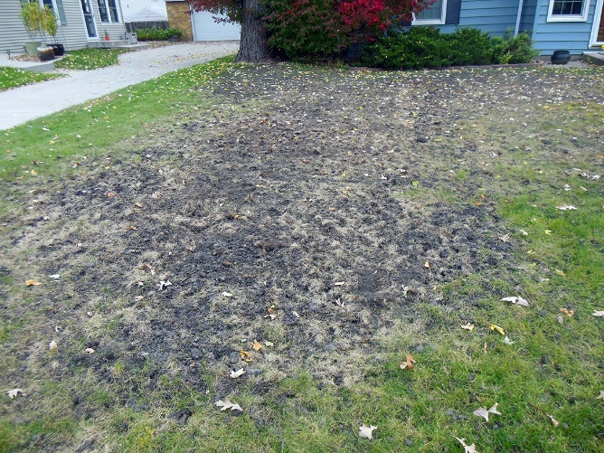

The chemicals in pool water are designed to kill pathogens and prevent living things from growing in your pool. If the water is disposed of improperly it has the potential to harm our lakes, rivers and streams and even the sewage treatment plant.

Pools hold a lot of water. Following the guidelines listed above it will make the disposal process legal and less likely to result in issues with the city or your neighbors.

For more information on proper pool water disposal and other pollution prevention strategies please visit [www.claremorecity.com/294/Water-Resources](http://www.claremorecity.com/294/Water-Resources).

**Disposal onto your property.** Take these steps to ensure disposal onto your property does not damage your or your neighbor’s yard.

* Discontinue adding chlorine and other chemicals at least 72 hours before draining onto your property. Make sure there is no chlorine and pH is near 7.
* Be aware that come chemicals and salt water can damage plants and soil. So you will want to make sure that your discarded pool water won’t damage your or your neighbor’s favorite plants and yard.



The chemicals in pool water are designed to kill pathogens and prevent living things from growing in your pool. If the water is disposed of improperly it has the potential to harm our lakes, rivers and streams and even the sewage treatment plant.

Pools hold a lot of water. Following the guidelines listed above it will make the disposal process legal and less likely to result in issues with the city or your neighbors.

For more information on proper pool water disposal and other pollution prevention strategies please visit [www.claremorecity.com/294/Water-Resources](http://www.claremorecity.com/294/Water-Resources)

**Disposal onto your property.** Take these steps to ensure disposal onto your property does not damage your or your neighbor’s yard.

* Discontinue adding chlorine and other chemicals at least 72 hours before draining onto your property. Make sure there is no chlorine and pH is near 7.
* Be aware that come chemicals and salt water can damage plants and soil. So you will want to make sure that your discarded pool water won’t damage your or your neighbor’s favorite plants and yard.



The chemicals in pool water are designed to kill pathogens and prevent living things from growing in your pool. If the water is disposed of improperly it has the potential to harm our lakes, rivers and streams and even the sewage treatment plant.

Pools hold a lot of water. Following the guidelines listed above it will make the disposal process legal and less likely to result in issues with the city or your neighbors.

For more information on proper pool water disposal and other pollution prevention strategies please visit [www.claremorecity.com/294/Water-Resources](http://www.claremorecity.com/294/Water-Resources)