Simple Solutions to Stormwater Pollution
Stormwater pollution is rainwater that has become contaminated with substances that have been introduced by humans such as chemicals, sediment and trash. In this brochure we explore some ways we can all prevent this kind of pollution from happening.
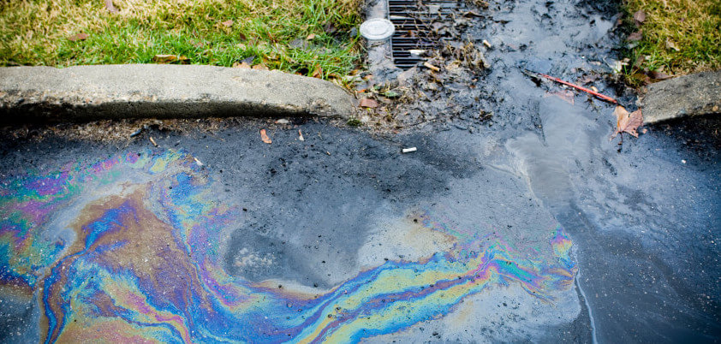
Here it is visible how pollutants on the ground and trash affect the quality of our water.
Here are a few ways you can help prevent stormwater pollution.
- Use lawn chemicals sparingly or not at all. Follow instruction on lawn chemicals if you have to use them. Look for ways to reduce using them or look for organic options that are less harmful.
- Use a mulching mower and blow leaves and grass back on to your yard.
Simple Solutions to Stormwater Pollution
Stormwater pollution is rainwater that has become contaminated with substances that have been introduced by humans such as chemicals, sediment and trash. In this brochure we explore some ways we can all prevent this kind of pollution from happening.
Here it is visible how pollutants on the ground and trash affect the quality of our water.
Here are a few ways you can help prevent stormwater pollution.
- Use lawn chemicals sparingly or not at all. Follow instruction on lawn chemicals if you have to use them. Look for ways to reduce using them or look for organic options that are less harmful.
- Use a mulching mower and blow leaves and grass back on to your yard.
Simple Solutions to Stormwater Pollution
Stormwater pollution is rainwater that has become contaminated with substances that have been introduced by humans such as chemicals, sediment and trash. In this brochure we explore some ways we can all prevent this kind of pollution from happening.
Here it is visible how pollutants on the ground and trash affect the quality of our water.
Here are a few ways you can help prevent stormwater pollution.
- Use lawn chemicals sparingly or not at all. Follow instruction on lawn chemicals if you have to use them. Look for ways to reduce using them or look for organic options that are less harmful.
- Use a mulching mower and blow leaves and grass back on to your yard.
- Make sure your car does not leak fluids onto the ground or concrete surfaces.
- Dispose of pool water properly. You may drain it into the sanitary sewer or onto your property. Never drain it into the street or storm drain because pool chemicals are harmful to stream inhabitants.
- Dispose of unused chemicals properly. Call The M.E.T at 918-584-0584 or visit their website at www.metrecycle.com for more information on chemical disposal.
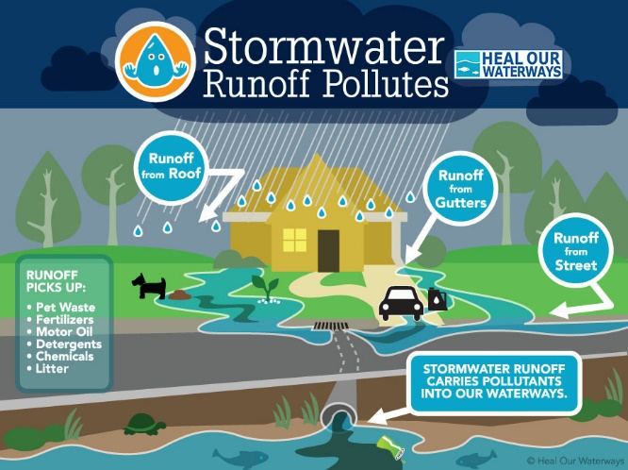
- Pick up after your pets. Pet waste contains harmful bacteria that will runoff into our streams during a rain. Dispose of pet waste in the trash or toilet.
- Clean and maintain septic tanks. Improperly maintained septic tanks can cause sewage to flood property and contaminate our waterways.
- Dispose of trash properly. Make sure your trash lids are closed and trash does not fly out of your vehicle.
We can all do our part to prevent stormwater pollution, and keep our land and water clean and healthy. For more information please visit the City of Claremore’s website at: https://www.claremorecity.com/315/Stormwater or call the Stormwater Manager, Julie Monnot at:
918-341-0457 ext. 285
- Make sure your car does not leak fluids onto the ground or concrete surfaces.
- Dispose of pool water properly. You may drain it into the sanitary sewer or onto your property. Never drain it into the street or storm drain because pool chemicals are harmful to stream inhabitants.
- Dispose of unused chemicals properly. Call The M.E.T at 918-584-0584 or visit their website at www.metrecycle.com for more information on chemical disposal.
- Pick up after your pets. Pet waste contains harmful bacteria that will runoff into our streams during a rain. Dispose of pet waste in the trash or toilet.
- Clean and maintain septic tanks. Improperly maintained septic tanks can cause sewage to flood property and contaminate our waterways.
- Dispose of trash properly. Make sure your trash lids are closed and trash does not fly out of your vehicle.
We can all do our part to prevent stormwater pollution and keep our land and water clean and healthy. For more information please visit the City of Claremore’s website at: https://www.claremorecity.com/315/Stormwater or call the Stormwater Manager, Julie Monnot at:
918-341-0457 ext. 285
- Make sure your car does not leak fluids onto the ground or concrete surfaces.
- Dispose of pool water properly. You may drain it into the sanitary sewer or onto your property. Never drain it into the street or storm drain because pool chemicals are harmful to stream inhabitants.
- Dispose of unused chemicals properly. Call The M.E.T at 918-584-0584 or visit their website at www.metrecycle.com for more information on chemical disposal.
- Pick up after your pets. Pet waste contains harmful bacteria that will runoff into our streams during a rain. Dispose of pet waste in the trash or toilet.
- Clean and maintain septic tanks. Improperly maintained septic tanks can cause sewage to flood property and contaminate our waterways.
- Dispose of trash properly. Make sure your trash lids are closed and trash does not fly out of your vehicle.
We can all do our part to prevent stormwater pollution and keep our land and water clean and healthy. For more information please visit the City of Claremore’s website at: https://www.claremorecity.com/315/Stormwater or call the Stormwater Manager, Julie Monnot at:
918-341-0457 ext. 285

